# Managing Data in Elasticsearch: Detailed Notes

## 1. Introduction

Now that we have everything set up, it’s almost time to add some documents to our cluster. In this section, we will learn how to manage data, starting with creating and deleting indices.

## 2. Creating and Deleting Indices

### 2.1 Deleting an Index

1. We will remove the 'pages' index created in the previous section.

2. Elasticsearch exposes a REST API. To delete an index, we use the HTTP verb 'DELETE', followed by the name of the index.

3. In Kibana's Console tool, a forward slash before the index name is optional but preferred.

4. Example Query:

DELETE /pages

5. Running this query will delete the 'pages' index.  
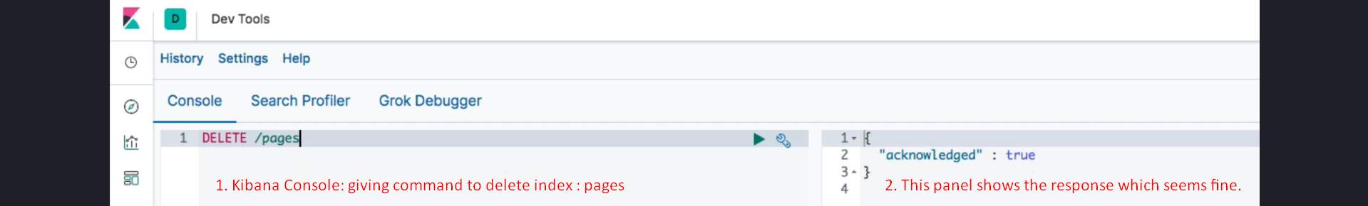

### 2.2 Creating an Index

1. To replace the 'pages' index, we will create a new index named 'products'.

2. The HTTP verb **'PUT' is used to create an index**.

3. We will specify the number of shards and replica shards for demonstration purposes. For production purposes, it is recommended to stick to default settings unless required otherwise.

4. To configure index settings, include a JSON object in the request body.

5. Example Query:

PUT /products  
{  
 "settings": {  
 "**number_of_shards**": 2,  
 "**number_of_replicas**": 2  
 }  
}

6. **Explanation of the settings**:

- **'number_of_shards'**: Specifies the number of shards for the index.

- **'number_of_replicas'**: Specifies the number of replica shards for the index.

7. **The response includes the following keys**:

- **'acknowledged'**: Indicates if the index was successfully created.

- **'shards_acknowledged'**: Indicates if the required number of primary shards started up before timing out.

## 3. Summary

1. We learned how to delete an index using the 'DELETE' HTTP verb.

2. We created an index with custom settings using the 'PUT' HTTP verb.

3. Important settings for an index include 'number_of_shards' and 'number_of_replicas'. These should generally be left as defaults for production use unless specific requirements dictate otherwise.

4. The JSON response indicates whether the operations were successful.